20.53: (Extra figures are given in the numerical answers for clarity.) a) The efficiency is 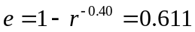, so the work done is 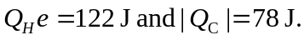 b) Denote the length of the cylinder when the piston is at point a by 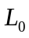and the stroke as s. Then, 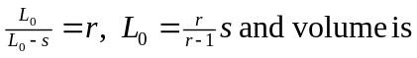

c) The calculations are presented symbolically, with numerical values substituted at the end. At point a, the pressure is as found in part (b) and the temperature is the pressure after the adiabatic compression is 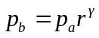 and the temperature is 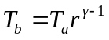. During the burning of the fuel, from 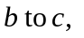the volume remains constant and so 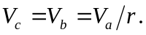 The temperature has changed by an amount
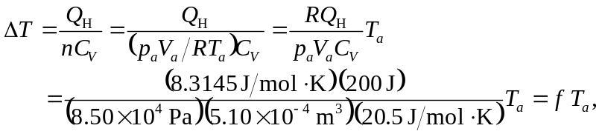
where f is a dimensionless constant equal to 1.871 to four figures. The temperature at c is then 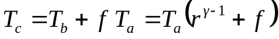. The pressure is found from the volume and temperature, 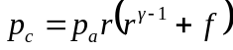. Similarly, the temperature at point d is found by considering the temperature change in going from d to a, 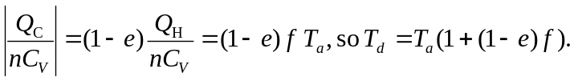The process from d to a is isochoric, so To summarize,

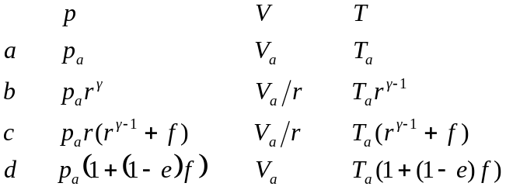

Using numerical values (and keeping all figures in the intermediate calculations),

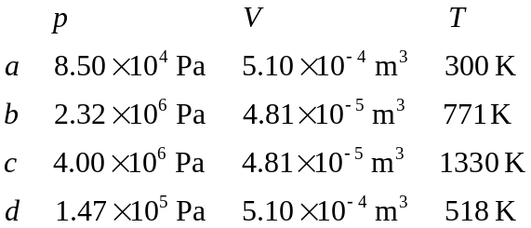

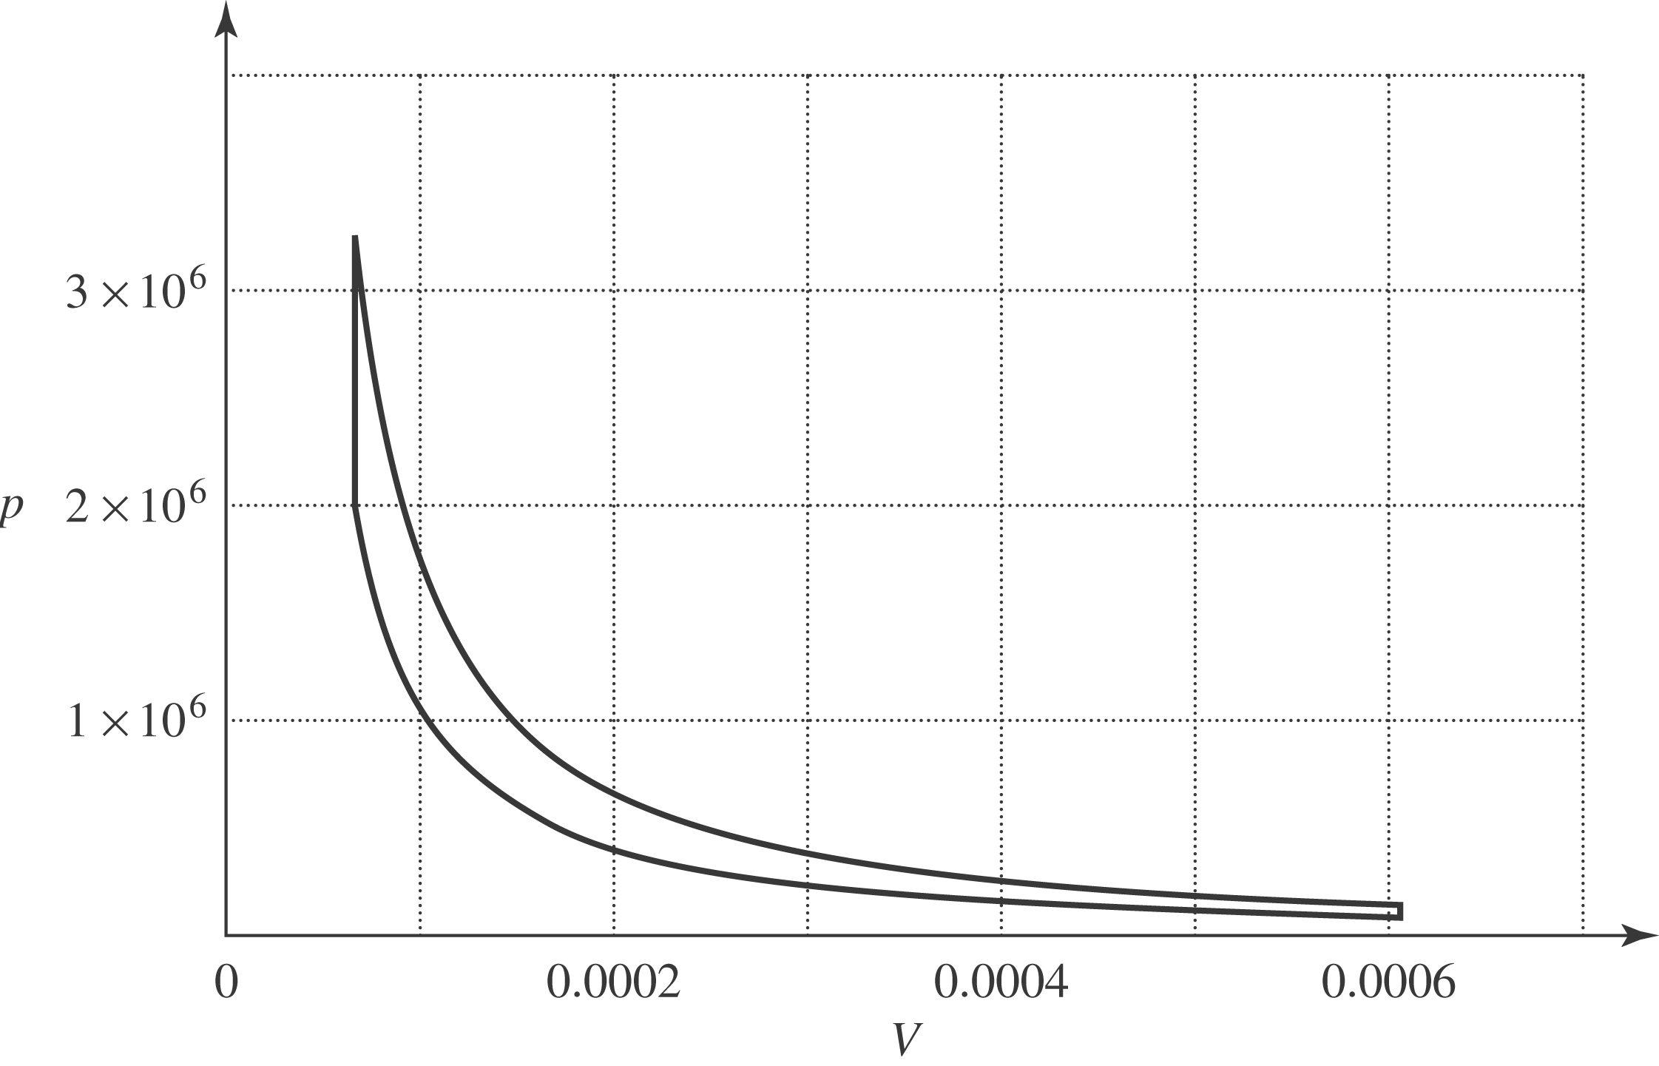

d) For this engine, 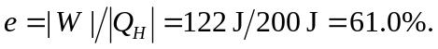 The maximum and minimum temperature are 1330 K and 300 K, and the efficiency is 